NAME: KAVITAPU SWARNA VARSHINI
REG.NO: 192324081
DATE: 14-07-2026

Write a python program for missionaries cannibal problem
AIM: To write a Python program to solve the Missionaries and Cannibals Problem using Breadth-First Search (BFS).
ALGORITHM:
- Represent the state as the number of missionaries, cannibals, and the boat position.
- Start from the initial state (3, 3, Left).
- Generate all valid successor states by moving one or two people across the river.
- Use Breadth-First Search (BFS) to find the shortest valid path while avoiding invalid states.
- Display the sequence of states from the initial state to the goal state.
CODE:
from collections import deque
def valid(m, c):
if m < 0 or c < 0 or m > 3 or c > 3:
return False
if (m > 0 and m < c):
return False
if (3 - m > 0 and 3 - m < 3 - c):
return False
return True
moves = [(1,0),(2,0),(0,1),(0,2),(1,1)]
start = (3,3,1) # (Missionaries, Cannibals, Boat Left=1)
goal = (0,0,0)
queue = deque([(start,[start])])
visited = set([start])
while queue:
state, path = queue.popleft()
if state == goal:
for s in path:
print(s)
break
m, c, boat = state
for dm, dc in moves:
if boat:
nm, nc, nb = m-dm, c-dc, 0
else:
nm, nc, nb = m+dm, c+dc, 1
new = (nm, nc, nb)
if valid(nm, nc) and new not in visited:
visited.add(new)
queue.append((new, path+[new]))
OUTPUT:
(3, 3, 1)
(3, 1, 0)
(3, 2, 1)
(3, 0, 0)
(3, 1, 1)
(1, 1, 0)
(2, 2, 1)
(0, 2, 0)
(0, 3, 1)
(0, 1, 0)
(1, 1, 1)
(0, 0, 0)
IMAGE:
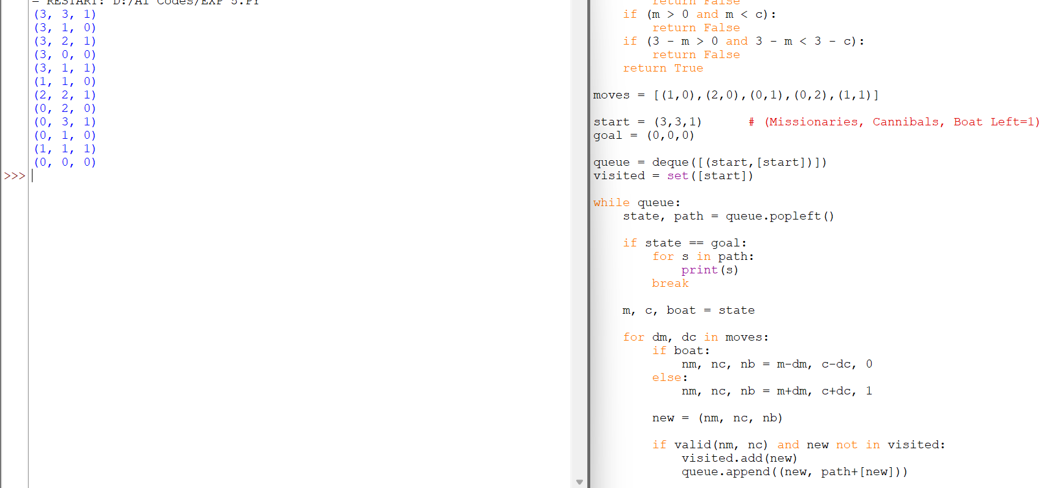

RESULT:
The Python program successfully solved the Missionaries and Cannibals Problem using Breadth-First Search (BFS) and found a valid sequence of moves to safely transport all missionaries and cannibals across the river without violating the problem constraints.

